## Table – Search Engine

Write a function that **searches** in a **table** by given input. Create a **template** for a **table row**, which can be **easily updated** with class values when the user performs a search. Load the data from the following URL with a GET request: **http://localhost:3030/jsonstore/advanced/table**

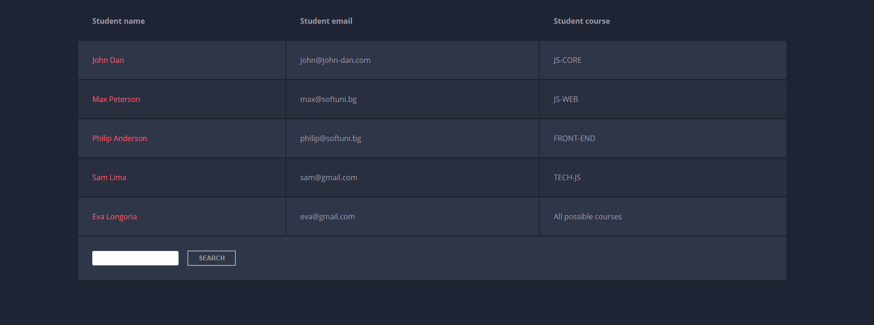

When the "**Search**" **button** is **clicked**, go through all cells in the table body and check if the given input is **included** anywhere. The search should be **case-insensitive**.

If any of the rows contains the submitted string, add a select class to that row. Note that more than one row may contain the given string. If there is no match **nothing** should be highlighted.

**Note:** After every search, **clear** **the input field** and **remove** **all already selected classes** (if any) from the previous search, in order for the **new search** to contain only the **new result**.

See the file example.html for an example of how the rendered HTML should look like.

### Example

For instance, if we try to find **eva:**

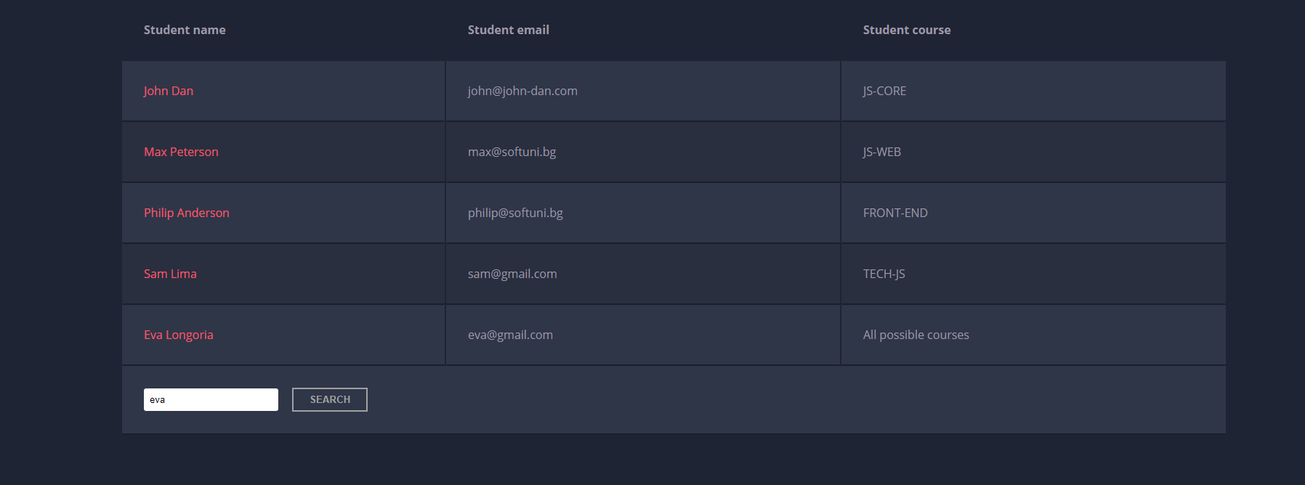

The result should be:

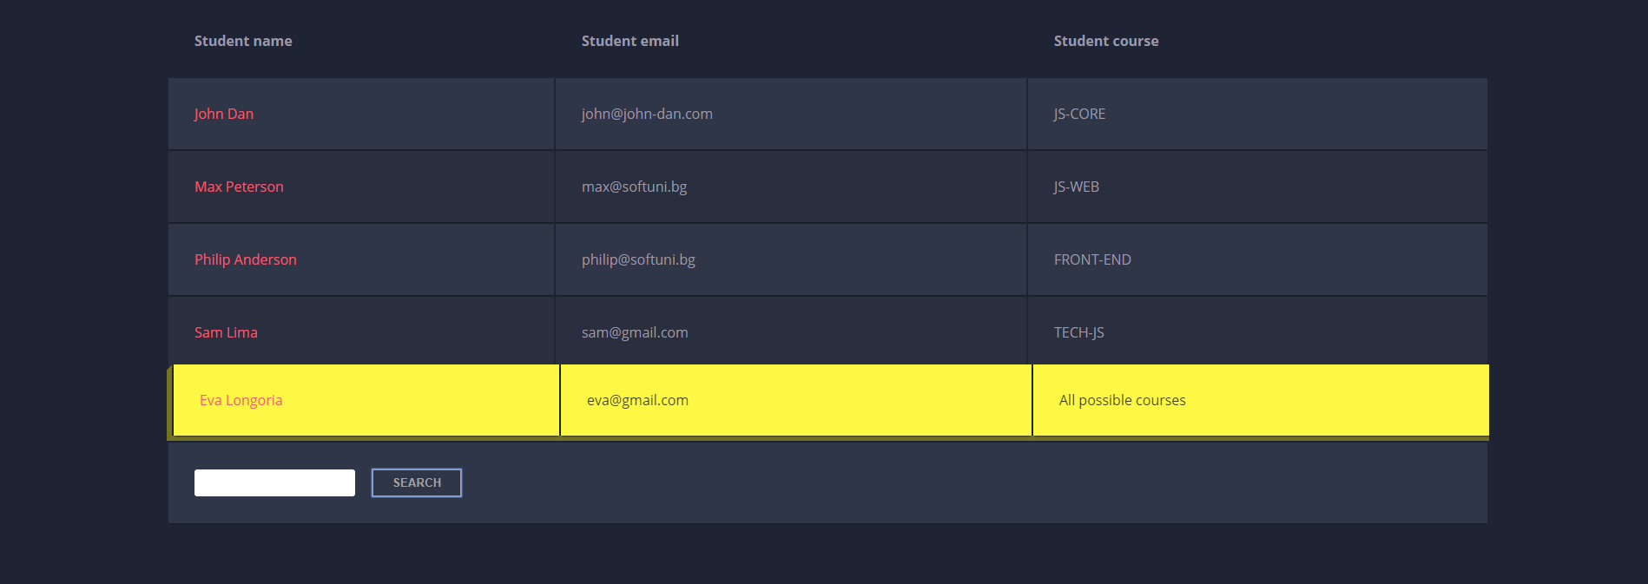

If we try to find all students who have email addresses in **softuni** domain, the expected result should be:

